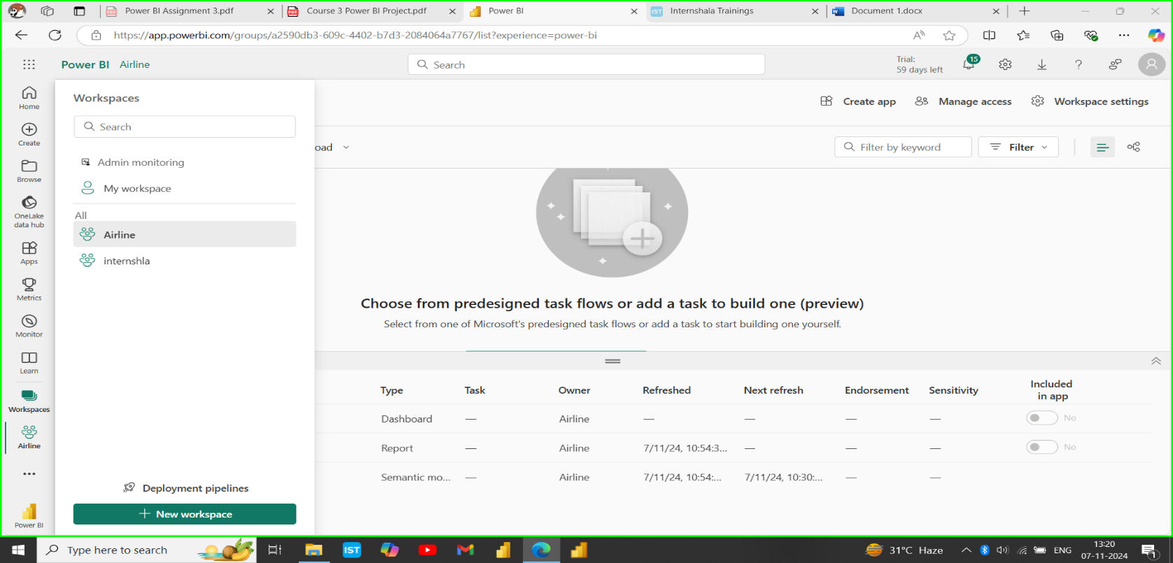**Workspace Airline -**

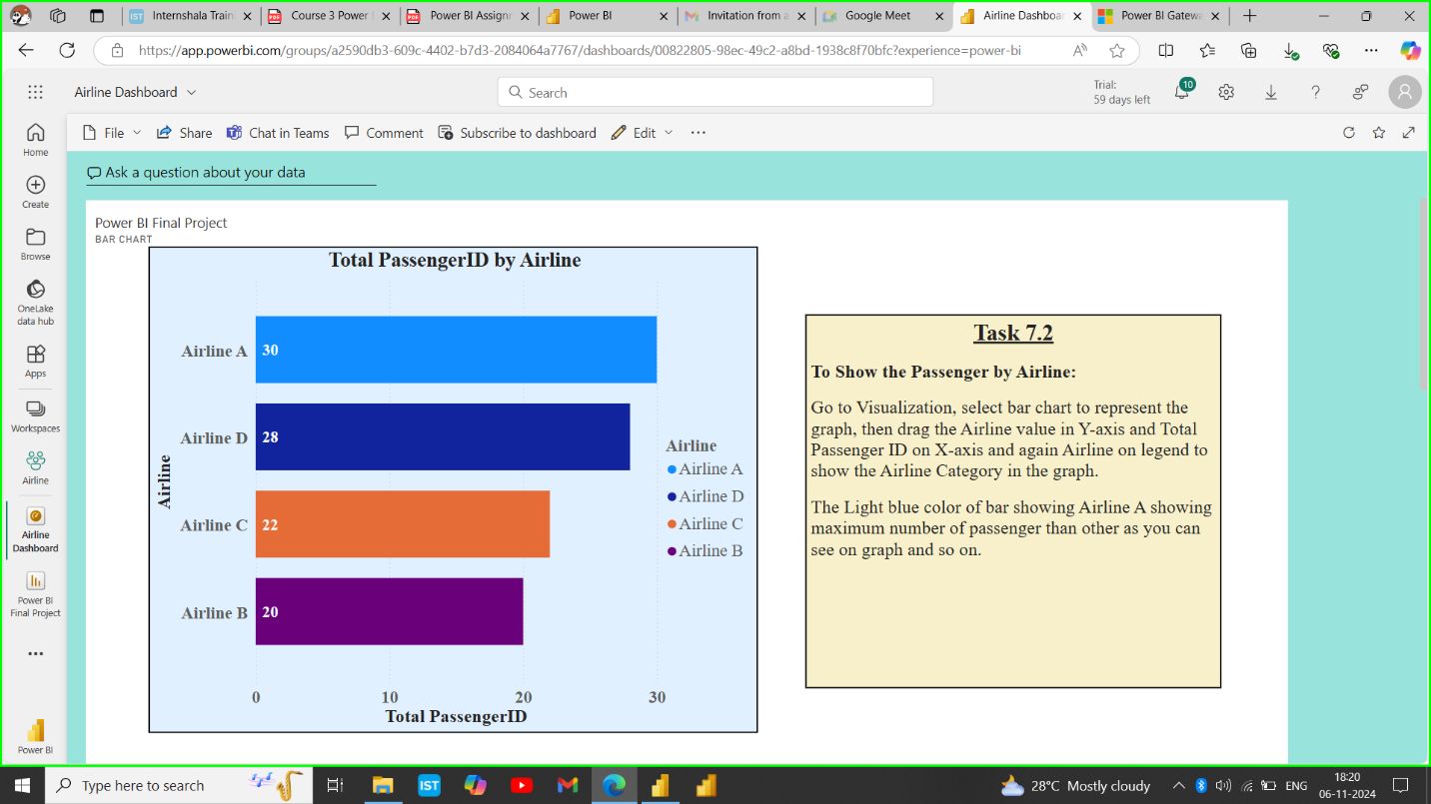**Dashboards –**

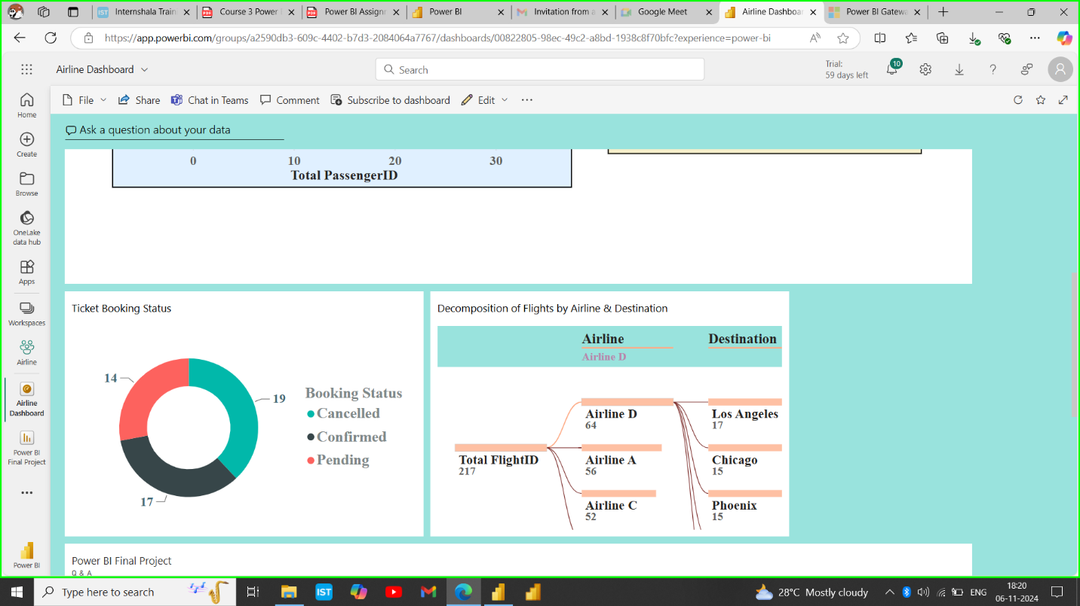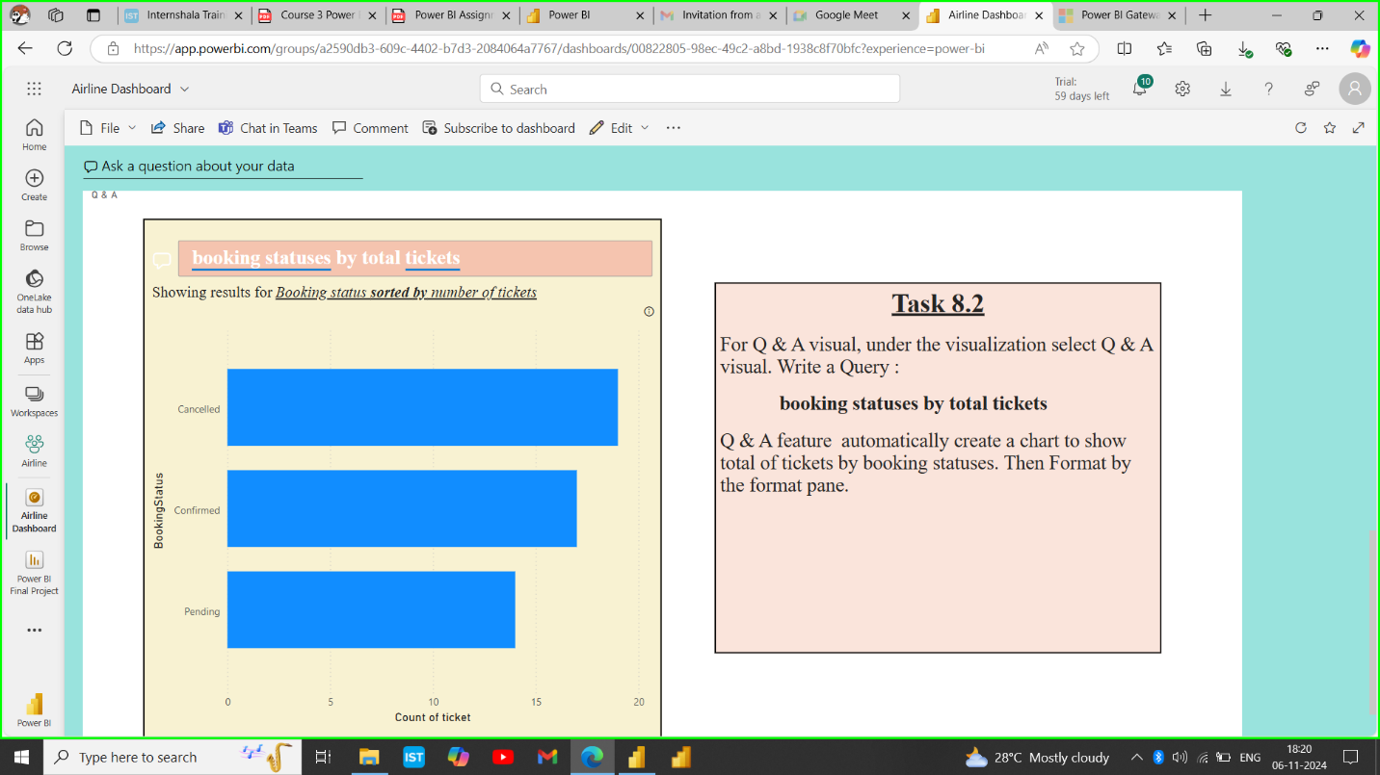

**RLS –**

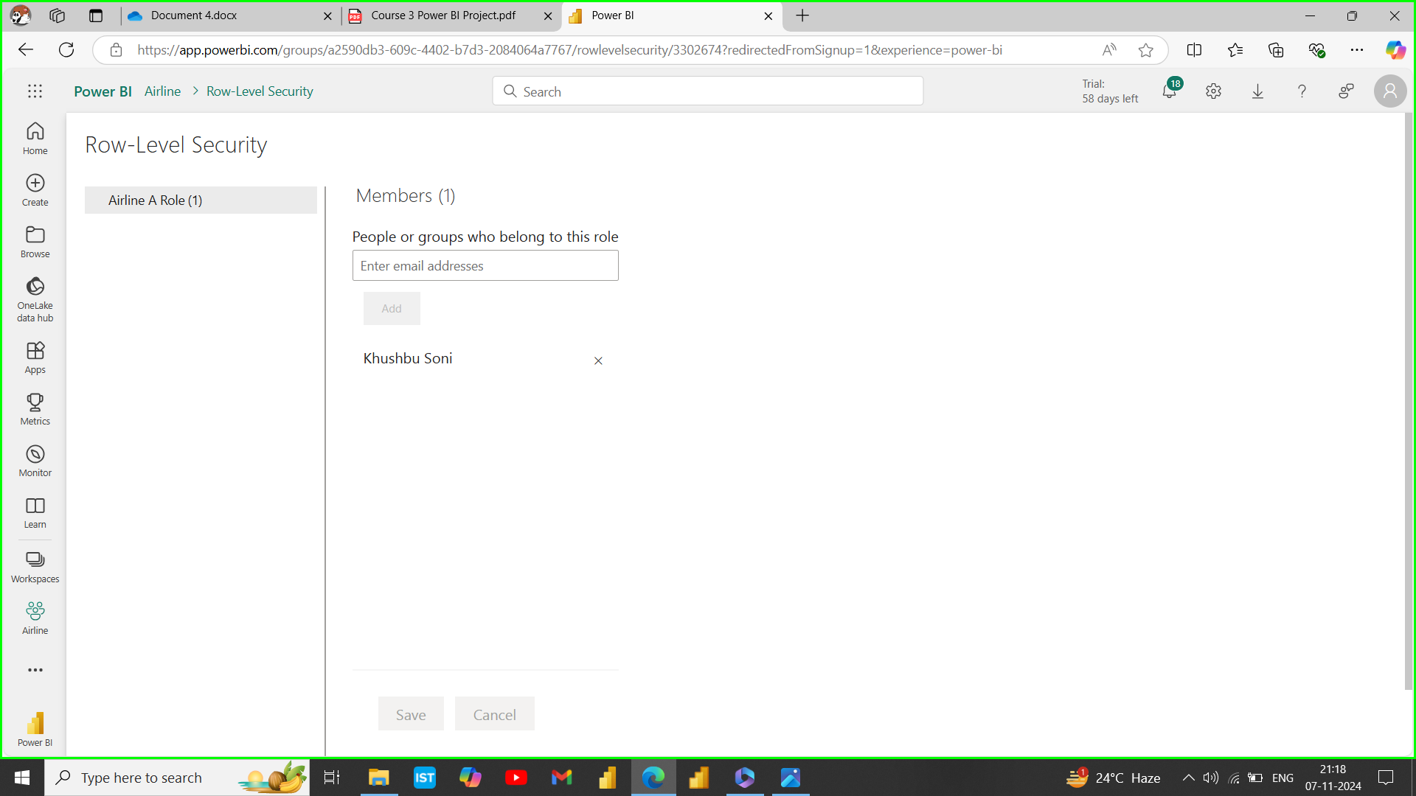

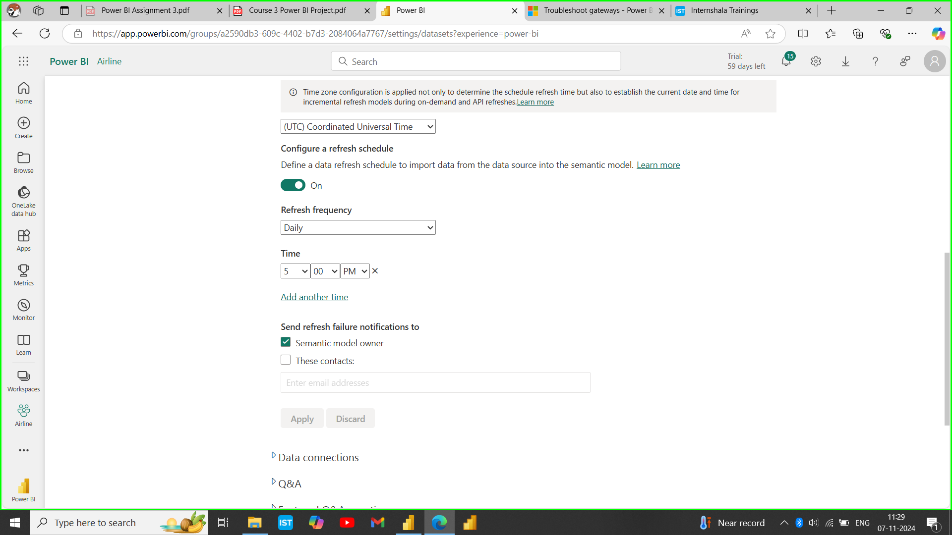**Referesh schedule at 5 PM –**

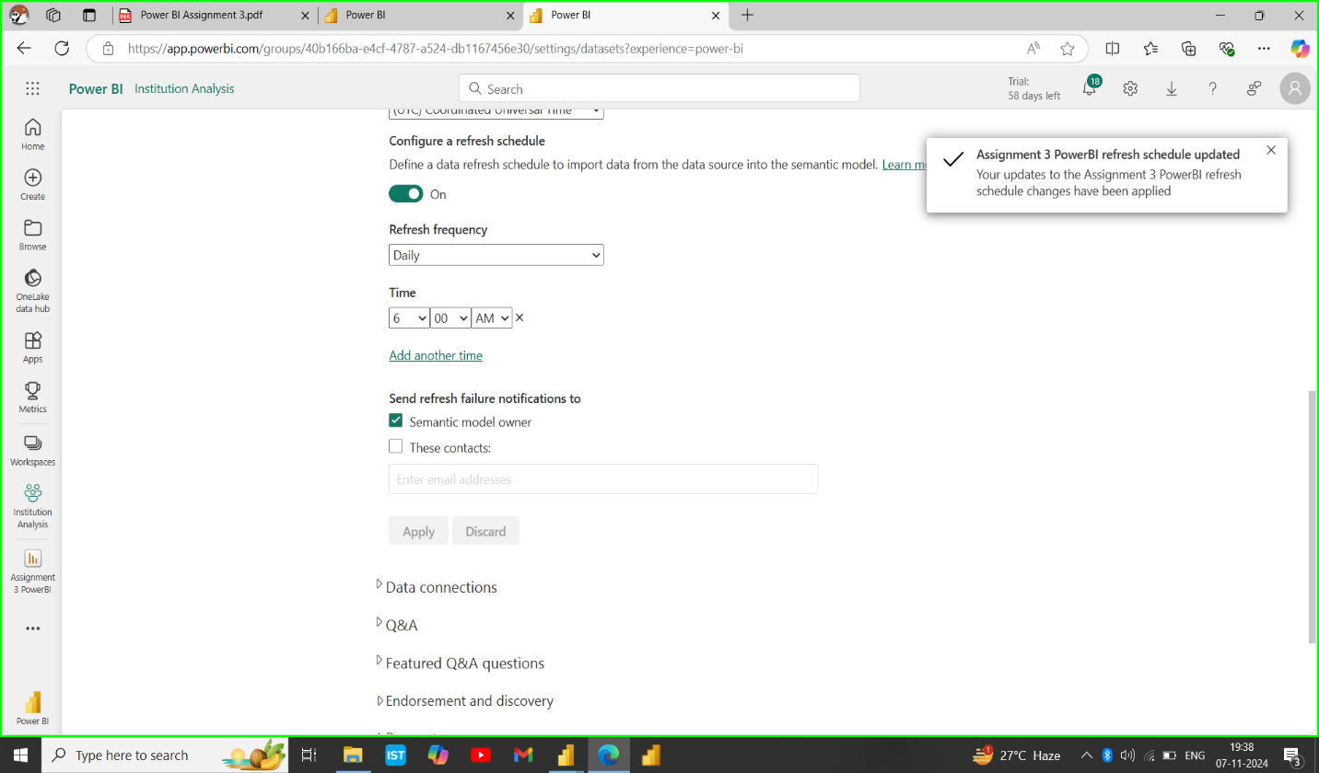**Assignment 3- refresh schedule at 6 AM –**

**I forgot to attached timezone referesh schedule in assignment 3. So, I am attaching here.**

**Here I am attaching my video link of project.**

[**https://drive.google.com/file/d/1QSjXQAapL5DTC3rGgqzu_627rn8_cBPf/view?usp=sharing**](https://drive.google.com/file/d/1QSjXQAapL5DTC3rGgqzu_627rn8_cBPf/view?usp=sharing)